CELEBRATING

A LIFE

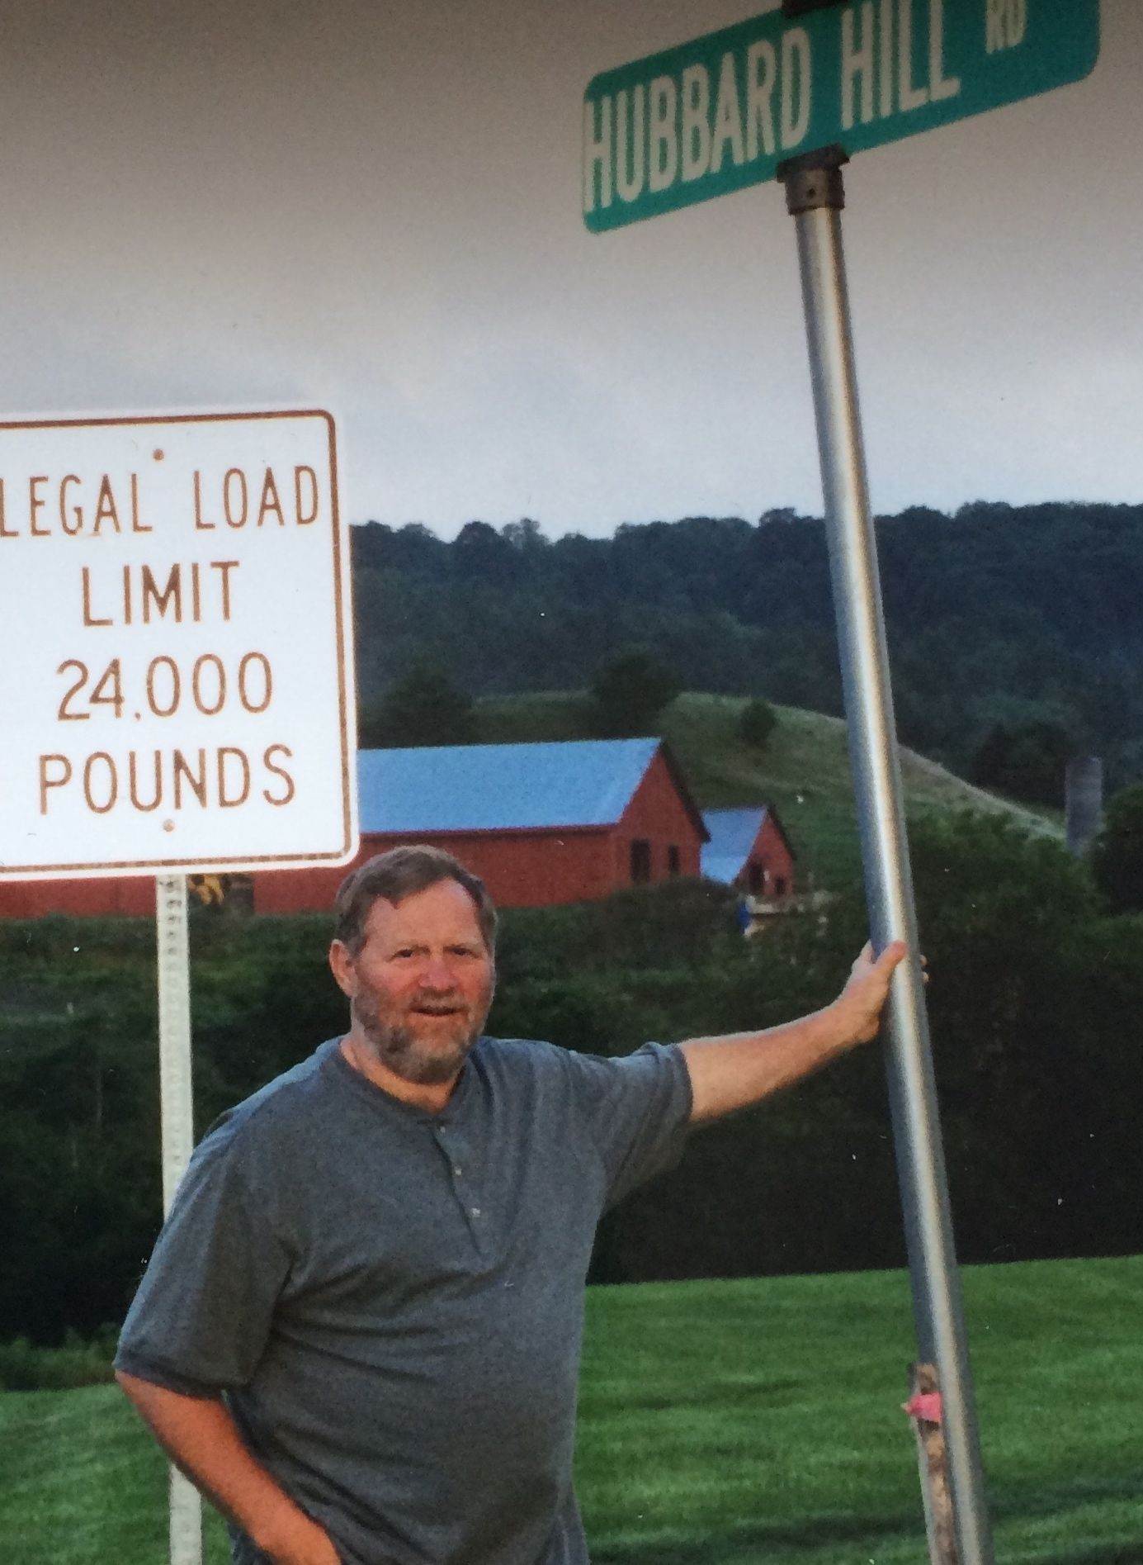

IN LOVING MEMORY OF

BRUCE CALVIN HUBBARD

JANUARY 23, 1949 – FEBRUARY 12, 2016

MAY 14, 2016

1:00 PM – 4:00PM

URBANA DISTRICT PARK

3805 URBANA PIKE

FREDERICK, MD 21704

COME AND SHARE

YOUR MEMORIES

**elizabeth hortie**

